A000-Asia-China-Hongshan-Cong-Jade-2 Tier

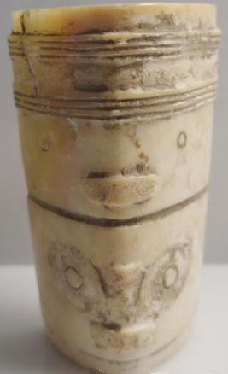

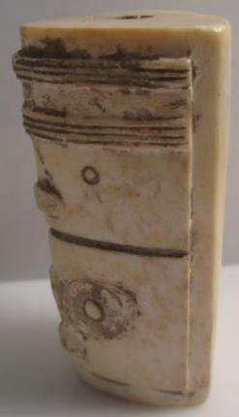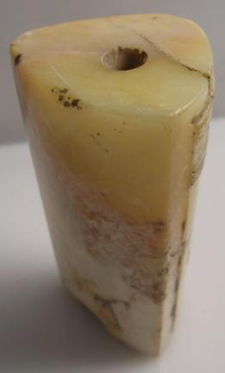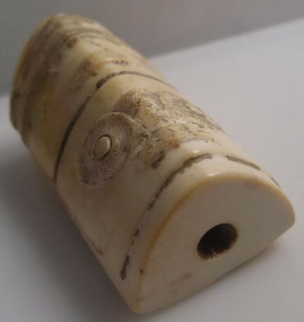

NK5750.2.A1
H: 5.8 cm. x W: 3.4 cm.
Material: Jade

Case No.: 5
Accession Number:
Formal Label:
Display Description:
Hongshan culture (紅山文化; pinyin: Hóngshān wénhuà) is a Neolithic culture in the Liao river basin from Inner Mongolia to Liaoning, and dated to 4700-2900 BCE. This Hongshan jade cong has two different masks, the top one depicting a deceased ancestor and the bottom one depicting the protective dragon. While it is diminutive in size this feature distinguishes it as being significant.

LC Classification:
Date or Time Horizon:
Geographical Area:
Map:
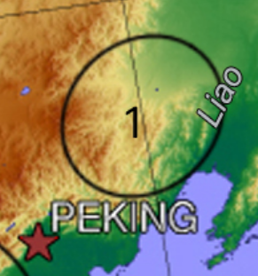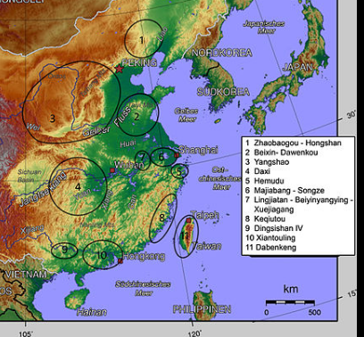
Hongshan in the Liao region and Chinese Neolithic cultures after map built with the help of Li Liu and Xingcan Chen : The Archaeology of China : From the Late Paleolithic to the Early Bronze Age, Cambridge University Press 2012, page 170. Compared to : Li Feng Early China, 2013. Page 19 : The "Chinese Interaction Spheres" map. After CC BY-SA 4.0

GPS Coordinates:
Cultural Affiliation:
Medium:
Dimensions:
Weight:
Provenance:
Condition:
Discussion:
References:

